
Section B: The Visual Narrative Audit
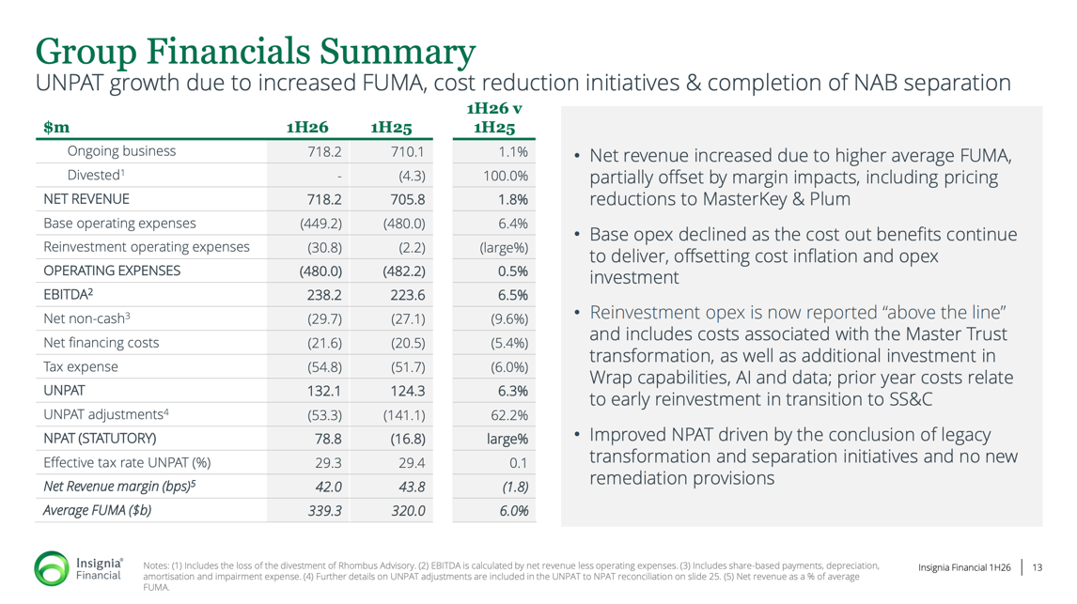
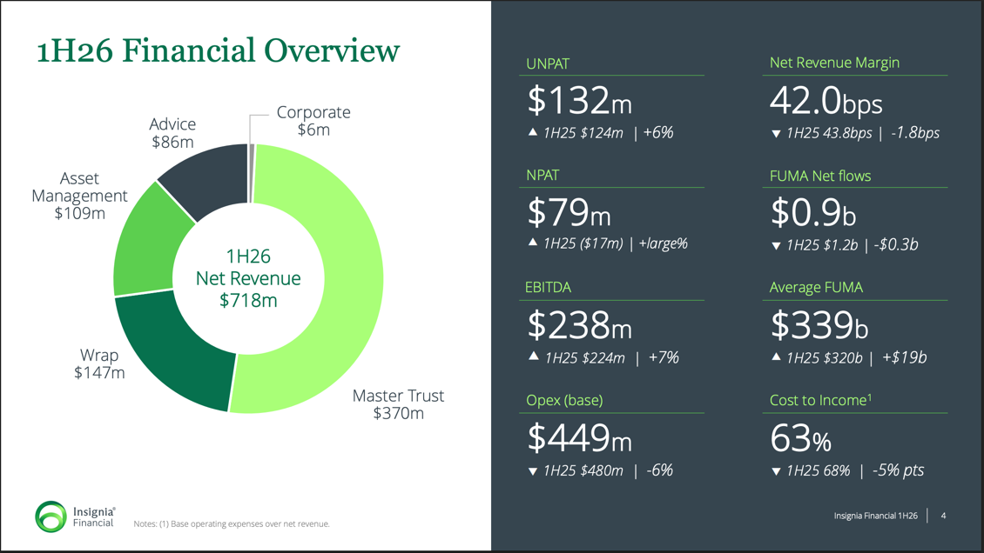

- Strategic Cause: The vibe that the company is projecting is growth, where they are focusing on improving profits and strong cost control. The report slides display how the company is becoming more stable (when comparing 1H25 to 1H26) and moving in the right direction to build investor confidence.

Slide 1: 1H26 Financial Overview
Gestalt Principle of Proximity: Related financial metrics are grouped together, making it easier for viewers to understand the performance trends. This grouping helps investors quickly see that net profits are increasing and costs are decreasing.

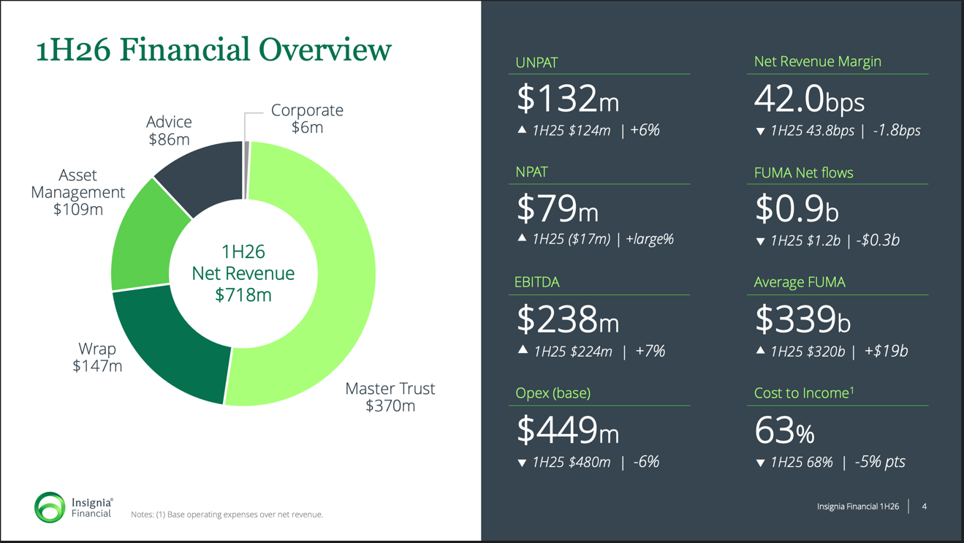
Visual Hierarchy: Central placement in green font puts emphasis on the growth for Net Revenue.

Pre-Attentive Attributes: Upward and downward arrows instantly signal growth or decline, directing attention to performance while the viewer reads numbers. Since shapes are processed subconsciously by the brain, the arrows help viewers instantly interpret the results.

Pre-Attentive Attributes: Master Trust is highlighted in a lighter green shade, making it easier to immediately identify as the largest revenue source. This visual cue reduces cognitive load and instantly highlights the attribute for revenue stability.
Visual Hierarchy: Large bold numbers help grab the viewers’ attention, guiding them to focus on important financial metrics. The dark blue /black background creates strong contrast, making the figures stand out and ensuring key insights are noticed.
viewers attention.

Slide 2: Financials Summary
Cognitive Load: The table provides clear columns with green font headings comparing 1H26 and 1H25 metrics, making it easier for viewers to quickly identify profit growth and reductions in expenses, in a year.


Cognitive Load: The bullet-point summary explains the key takeaways from the table, helping viewers understand the results with less effort. This reduces cognitive load by showing complex financial numbers in a clear way.
Visual Hierarchy: Capitalized, bold text draws attention to the most important financial metrics. This helps the key figures stand out and ensures that they are quickly noticed.

Data-ink Ratio: The table uses a simple layout with minimal colors and no unnecessary graphics, which allows viewers to focus directly on the financial information. This design reduces distractions and highlights the key financial insights, making the data easier to read.

- Synthesis:
After evaluating the company slides and the exploratory data audit (Part A), it can be seen that the slides align with the financial data and market trends observed in Part A. The company’s slides display a strong “growth and stability” vibe. This is shown through the use of theories such as visual hierarchy, pre-attentive attributes and clear presentation of data. This focuses the viewers’ attention on the metrics that cause improvements in financial performance of the company.
In the 1H26 Financial Overview slide, design elements such as arrows, bold numbers, charts and color contrast highlight revenue metrics. These visuals help viewers to interpret the results as financially strong and improving. This observation is seen to be consistent with the data analyzed in Part A. Around the announcement date, the stock price showed a gradual increase from T−4 to T+5 days, suggesting that the stock has gained value and investors reacted positively to the announcement. The company’s results day P/E ratio of 27.8× is higher than the index of 21.6×, showing stronger investor confidence for Insignia Financial. The company also reported a higher EPS compared to its previous period, meaning profitability per share improved. This supports the growth message shown in the slides.
The Group Financials Summary slide also supports growth and stability by highlighting NPAT growth and declining operating expenses from 1H25 to 1H26. The bullet points on the right summarize that the revenue increased while costs decreased. This causes slight friction as the positive metrics are summarized more clearly, while weaker metrics such as the decline in net revenue margin have less emphasis. This reduces attention on weaker performance’s and creates a more positive impression for stakeholders. Overall, the slides still largely align with the data from Part A, as the company shows improving profitability and contains more positive metrics than weaker ones.

